**Program Dinamis Mundur**

Nama : Jessica Julia Paradina Siregar

NIM : 09021281722032

Menentukan lintasan terpendek menggunakan PD mundur

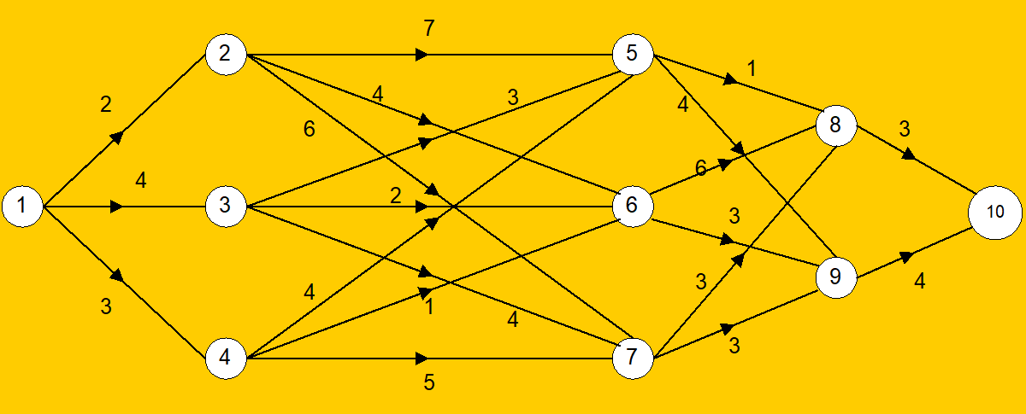

Rute yang dilalui adalah x4 -> x3 -> x2 -> x1. x4 diketahui 10

Tahapan :

Tahap 1 :

|  |  |  |
| --- | --- | --- |
| s | Solusi optimum | |
| f(4) | x4 |
| 8 | 3 | 10 |
| 9 | 4 | 10 |

Tahap 2 :

|  |  |  |  |  |
| --- | --- | --- | --- | --- |
| s \ x3 | *f3 (x3,s) = cx3,s + f4(x3)* | | Solusi optimum | |
| 8 | 9 | *f3(s)* | *x3* |
| 5 | 4 | 8 | 4 | 8 |
| 6 | 9 | 7 | 7 | 9 |
| 7 | 6 | 7 | 6 | 9 |

Tahap 3 :

|  |  |  |  |  |  |
| --- | --- | --- | --- | --- | --- |
| s \ x2 | *f2(x2, s) = cx2,s + f3(x2)* | | | Solusi optimum | |
| 5 | 6 | 7 | *f2(s)* | *x2* |
| 2 | 11 | 11 | 12 | 11 | 5 atau 6 |
| 3 | 7 | 9 | 10 | 7 | 5 |
| 4 | 8 | 8 | 11 | 8 | 5 atau 6 |

Tahap 4 :

|  |  |  |  |  |  |
| --- | --- | --- | --- | --- | --- |
| s \ x1 | *f1(x1, s) = cx1,s + f2(x1)* | | | Solusi optimum | |
| 2 | 3 | 4 | *f1(s)* | *x1* |
| 1 | 13 | 11 | 11 | 11 | 3 atau 4 |